1-H.323

📞 What is H.323?
# Source: Chatgpt (GPT-5-Mini) at [1/18/2026]
H.323 is an ITU-T standard for real-time voice, video, and data communication over IP networks — such as LANs and the Internet.
🔹 Think of H.323 as one of the earliest complete VoIP and video conferencing protocols — developed before SIP became widely popular.

🧱 H.323 Is a Suite of Protocols
# Source: Chatgpt (GPT-5-Mini) at [1/18/2026]
H.323 isn't just one protocol — it includes multiple components for handling different parts of a real-time communication session:
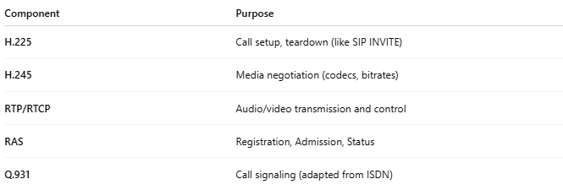
Component | Purpose
H.225 | Call setup, teardown (like SIP INVITE)
H.245 | Media negotiation (codecs, bitrates)
RTP/RTCP | Audio/video transmission and control
RAS | Registration, Admission, Status
Q.931 | Call signaling (adapted from ISDN)

🧰 H.323 Entities
# Source: Chatgpt (GPT-5-Mini) at [1/18/2026]
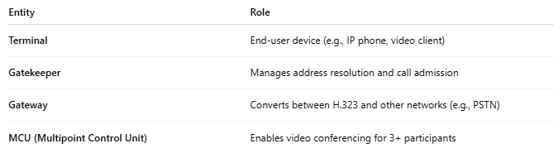
Entity | Role
Terminal | End-user device (e.g., IP phone, video client)
Gatekeeper | Manages address resolution and call admission
Gateway | Converts between H.323 and other networks (e.g., PSTN)
MCU (Multipoint Control Unit) | Enables video conferencing for 3+ participants

📡 H.323 Call Flow (Simplified)
# Source: Chatgpt (GPT-5-Mini) at [1/18/2026]
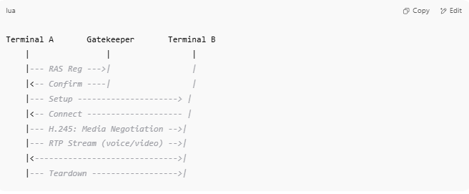
Terminal A Gatekeeper Terminal B
| | |
|--- RAS Reg --->| |
|<-- Confirm ----| |
|--- Setup ---------------------> |
|<-- Connect -------------------- |
|--- H.245: Media Negotiation -->|
|--- RTP Stream (voice/video) -->|
|<------------------------------>|
|--- Teardown ------------------>|

🆚 H.323 vs SIP
# Source: Chatgpt (GPT-5-Mini) at [1/18/2026]
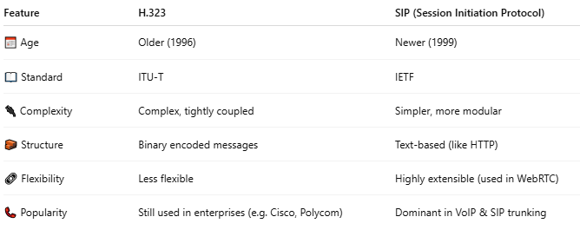
Feature | H.323 | SIP (Session Initiation Protocol)
📅 Age | Older (1996) | Newer (1999)
📖 Standard | ITU-T | IETF
🔌 Complexity | Complex, tightly coupled | Simpler, more modular
🧱 Structure | Binary encoded messages | Text-based (like HTTP)
🔗 Flexibility | Less flexible | Highly extensible (used in WebRTC)
📞 Popularity | Still used in enterprises (e.g. Cisco, Polycom) | Dominant in VoIP & SIP trunking

✅ Where H.323 Is Still Used
# Source: Chatgpt (GPT-5-Mini) at [1/18/2026]
- Enterprise video conferencing systems (e.g., Cisco, Avaya)
- Legacy VoIP phone systems
- Interoperability with SIP via gateways
- Government and defense systems that require ITU standards

📊 H.323 vs SIP — Architecture Diagram

🧱 H.323 Architecture (Tightly Coupled)
# Source: Chatgpt (GPT-5-Mini) at [1/18/2026]
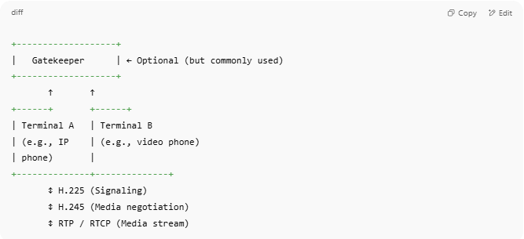
+-------------------+
| Gatekeeper | ← Optional (but commonly used)
+-------------------+
↑ ↑
+------+ +------+
| Terminal A | Terminal B
| (e.g., IP | (e.g., video phone)
| phone) |
+--------------+--------------+
↕ H.225 (Signaling)
↕ H.245 (Media negotiation)
↕ RTP / RTCP (Media stream)

- Gatekeeper controls call routing, admission, bandwidth.
- H.225 + H.245 manage signaling and negotiation.
- RTP is used for actual audio/video.

🌐 SIP Architecture (Loosely Coupled & Modular)
# Source: Chatgpt (GPT-5-Mini) at [1/18/2026]

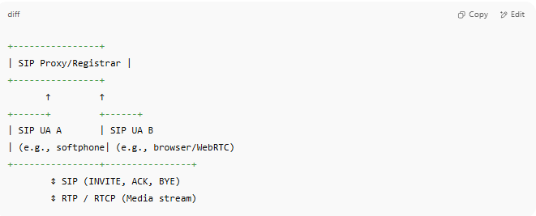
+----------------+
| SIP Proxy/Registrar |
+----------------+
↑ ↑
+------+ +------+
| SIP UA A | SIP UA B
| (e.g., softphone| (e.g., browser/WebRTC)
+----------------+----------------+
↕ SIP (INVITE, ACK, BYE)
↕ RTP / RTCP (Media stream)

- SIP handles signaling like HTTP (text-based).
- No media negotiation layer (like H.245)—everything in SDP (Session Description Protocol).
- SIP is modular and more flexible.

🆚 Side-by-Side: H.323 vs SIP
# Source: Chatgpt (GPT-5-Mini) at [1/18/2026]

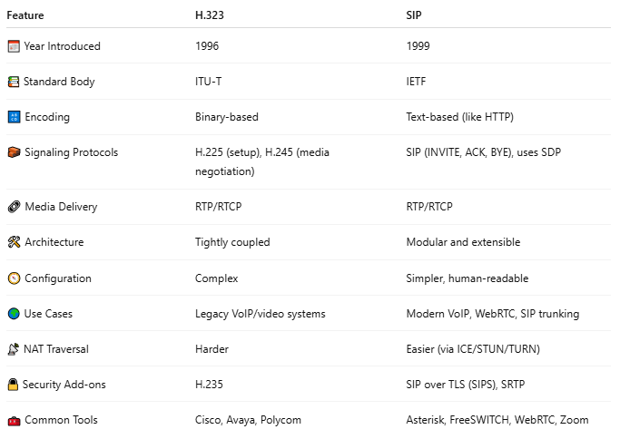
Feature | H.323 | SIP
📅 Year Introduced | 1996 | 1999
📚 Standard Body | ITU-T | IETF
🔠 Encoding | Binary-based | Text-based (like HTTP)
🧱 Signaling Protocols | H.225 (setup), H.245 (media negotiation) | SIP (INVITE, ACK, BYE), uses SDP
🔗 Media Delivery | RTP/RTCP | RTP/RTCP
🛠️ Architecture | Tightly coupled | Modular and extensible
🧭 Configuration | Complex | Simpler, human-readable
🌍 Use Cases | Legacy VoIP/video systems | Modern VoIP, WebRTC, SIP trunking
📡 NAT Traversal | Harder | Easier (via ICE/STUN/TURN)
🔒 Security Add-ons | H.235 | SIP over TLS (SIPS), SRTP
🧰 Common Tools | Cisco, Avaya, Polycom | Asterisk, FreeSWITCH, WebRTC, Zoom

🧠 In Simple Words:
# Source: Chatgpt (GPT-5-Mini) at [1/18/2026]
- H.323 = "Enterprise-grade VoIP protocol from the 90s"
- SIP = "Modern, internet-friendly, simpler protocol that powers apps like Zoom, WhatsApp, and WebRTC"

Would you like a call flow comparison between H.323 and SIP? Or a recommendation on when to use which?

✅ Summary
# Source: Chatgpt (GPT-5-Mini) at [1/18/2026]
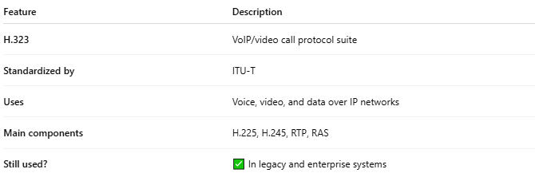
Feature | Description
H.323 | VoIP/video call protocol suite
Standardized by | ITU-T
Uses | Voice, video, and data over IP networks
Main components | H.225, H.245, RTP, RAS
Still used? | ✅ In legacy and enterprise systems

2-MGCP

📞 What is MGCP (Media Gateway Control Protocol)?
# Source: Chatgpt (GPT-5-Mini) at [1/18/2026]
MGCP stands for Media Gateway Control Protocol — it is a telecommunication signaling protocol used to control media gateways on IP networks, especially in VoIP (Voice over IP) systems.
🔧 Think of MGCP as a "master/slave" protocol, where a central controller tells media gateways exactly what to do — it does not support peer-to-peer communication like SIP or H.323.

🧱 MGCP System Components
# Source: Chatgpt (GPT-5-Mini) at [1/18/2026]
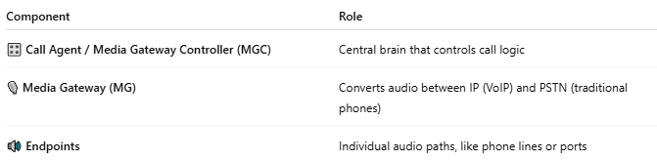
Component | Role
🎛️ Call Agent / Media Gateway Controller (MGC) | Central brain that controls call logic
🎙️ Media Gateway (MG) | Converts audio between IP (VoIP) and PSTN (traditional phones)
🔊 Endpoints | Individual audio paths, like phone lines or ports

🧩 MGCP Architecture Diagram
# Source: Chatgpt (GPT-5-Mini) at [1/18/2026]
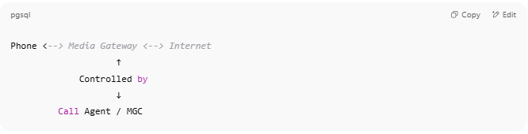
Phone <--> Media Gateway <--> Internet
↑
Controlled by
↓
Call Agent / MGC

- The Call Agent tells the Gateway: "Play a dial tone", "Start sending RTP to this IP", etc.
- The Media Gateway is passive and just executes commands.

⚙️ MGCP Command Examples
# Source: Chatgpt (GPT-5-Mini) at [1/18/2026]
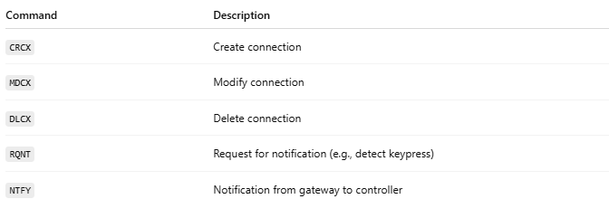
Command | Description
CRCX | Create connection
MDCX | Modify connection
DLCX | Delete connection
RQNT | Request for notification (e.g., detect keypress)
NTFY | Notification from gateway to controller

🔄 Comparison: MGCP vs SIP vs H.323
# Source: Chatgpt (GPT-5-Mini) at [1/18/2026]
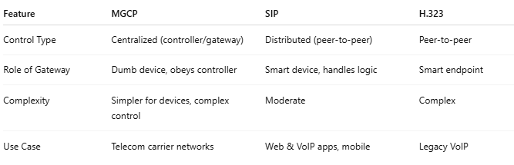
Feature | MGCP | SIP | H.323
Control Type | Centralized (controller/gateway) | Distributed (peer-to-peer) | Peer-to-peer
Role of Gateway | Dumb device, obeys controller | Smart device, handles logic | Smart endpoint
Complexity | Simpler for devices, complex control | Moderate | Complex
Use Case | Telecom carrier networks | Web & VoIP apps, mobile | Legacy VoIP

✅ MGCP Use Cases
# Source: Chatgpt (GPT-5-Mini) at [1/18/2026]
- Telephone company (carrier) VoIP systems
- Cable VoIP systems (e.g., Comcast, ISPs)
- Hybrid PSTN + VoIP networks
- Replacing traditional PBXs with VoIP-controlled gateways

🛑 Why MGCP Is Rare Today
# Source: Chatgpt (GPT-5-Mini) at [1/18/2026]
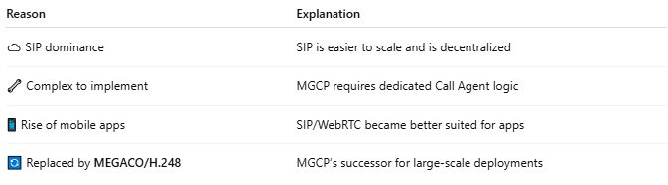
Reason | Explanation
☁️ SIP dominance | SIP is easier to scale and is decentralized
🔧 Complex to implement | MGCP requires dedicated Call Agent logic
📱 Rise of mobile apps | SIP/WebRTC became better suited for apps
🔄 Replaced by MEGACO/H.248 | MGCP’s successor for large-scale deployments

🧭 Architecture Diagrams

1. MGCP – Master/Slave Model
# Source: Chatgpt (GPT-5-Mini) at [1/18/2026]

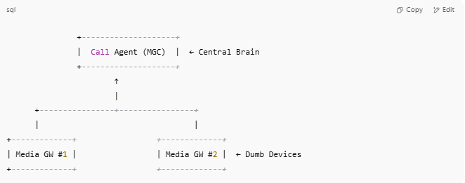
+--------------------+
| Call Agent (MGC) | ← Central Brain
+--------------------+
↑
|
+----------------+----------------+
| |
+-------------+ +-------------+
| Media GW #1 | | Media GW #2 | ← Dumb Devices
+-------------+ +-------------+

🧠 The Call Agent gives precise control commands to Media Gateways (MGs), which just execute them.

2. SIP – Peer-to-Peer Model
# Source: Chatgpt (GPT-5-Mini) at [1/18/2026]

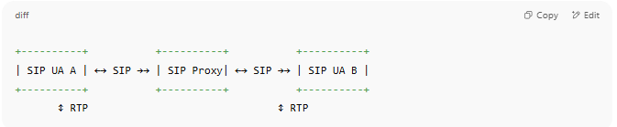
+----------+ +----------+ +----------+
| SIP UA A | ←→ SIP →→ | SIP Proxy| ←→ SIP →→ | SIP UA B |
+----------+ +----------+ +----------+
↕ RTP ↕ RTP

🤝 SIP endpoints are intelligent peers: they handle their own call logic and media negotiation.

3. MEGACO / H.248 – Successor to MGCP
# Source: Chatgpt (GPT-5-Mini) at [1/18/2026]
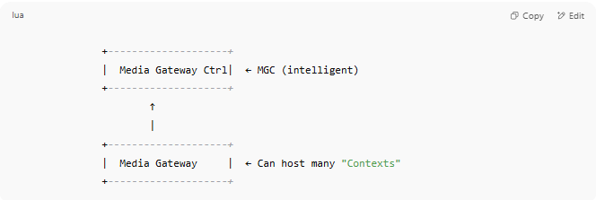
+--------------------+
| Media Gateway Ctrl| ← MGC (intelligent)
+--------------------+
↑
|
+--------------------+
| Media Gateway | ← Can host many "Contexts"
+--------------------+

🧠 MEGACO scales better, supports thousands of media endpoints per gateway, and adds more complex media control.

📊 MGCP vs SIP vs MEGACO (Side-by-Side)
# Source: Chatgpt (GPT-5-Mini) at [1/18/2026]

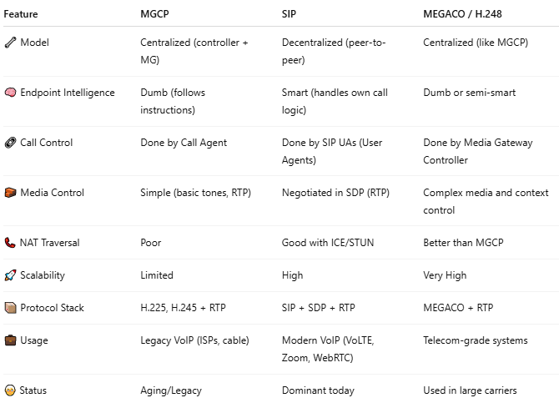
Feature | MGCP | SIP | MEGACO / H.248
🔧 Model | Centralized (controller + MG) | Decentralized (peer-to-peer) | Centralized (like MGCP)
🧠 Endpoint Intelligence | Dumb (follows instructions) | Smart (handles own call logic) | Dumb or semi-smart
🔗 Call Control | Done by Call Agent | Done by SIP UAs (User Agents) | Done by Media Gateway Controller
🧱 Media Control | Simple (basic tones, RTP) | Negotiated in SDP (RTP) | Complex media and context control
📞 NAT Traversal | Poor | Good with ICE/STUN | Better than MGCP
🚀 Scalability | Limited | High | Very High
📦 Protocol Stack | H.225, H.245 + RTP | SIP + SDP + RTP | MEGACO + RTP
💼 Usage | Legacy VoIP (ISPs, cable) | Modern VoIP (VoLTE, Zoom, WebRTC) | Telecom-grade systems
🧓 Status | Aging/Legacy | Dominant today | Used in large carriers

🛠️ Sample MGCP Commands (Simplified)
# Source: Chatgpt (GPT-5-Mini) at [1/18/2026]
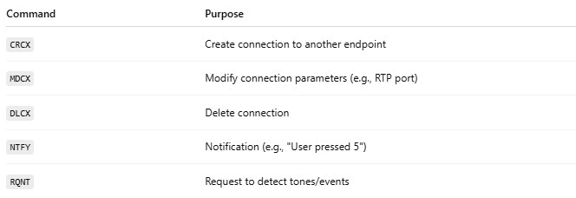
Command | Purpose
CRCX | Create connection to another endpoint
MDCX | Modify connection parameters (e.g., RTP port)
DLCX | Delete connection
NTFY | Notification (e.g., "User pressed 5")
RQNT | Request to detect tones/events
Example:
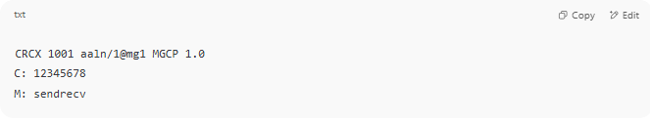
CRCX 1001 aaln/1@mg1 MGCP 1.0
C: 12345678
M: sendrecv

✅ Summary
# Source: Chatgpt (GPT-5-Mini) at [1/18/2026]
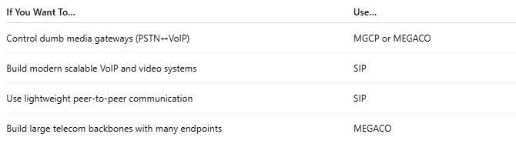
If You Want To… | Use…
Control dumb media gateways (PSTN↔VoIP) | MGCP or MEGACO
Build modern scalable VoIP and video systems | SIP
Use lightweight peer-to-peer communication | SIP
Build large telecom backbones with many endpoints | MEGACO

Would you like:
- 🔄 A real-world use case where SIP and MGCP are combined?
- 💻 Sample configuration for MGCP in Asterisk or FreeSWITCH?
- 📺 Or how this applies to modern IP phones or carriers?

✅ Summary
# Source: Chatgpt (GPT-5-Mini) at [1/18/2026]

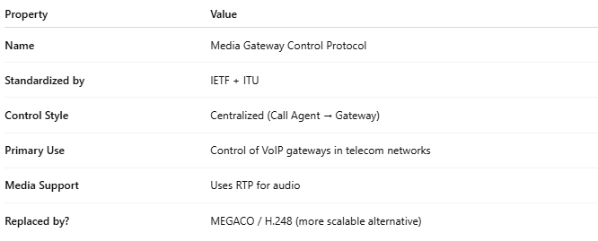
Property | Value
Name | Media Gateway Control Protocol
Standardized by | IETF + ITU
Control Style | Centralized (Call Agent → Gateway)
Primary Use | Control of VoIP gateways in telecom networks
Media Support | Uses RTP for audio
Replaced by? | MEGACO / H.248 (more scalable alternative)

3-SCCP

📞 What is SCCP (Skinny Client Control Protocol)?
# Source: Chatgpt (GPT-5-Mini) at [1/18/2026]
SCCP, also known as Skinny, stands for Skinny Client Control Protocol. It's a proprietary VoIP protocol developed by Cisco to allow IP phones to communicate with Cisco CallManager (now Cisco Unified Communications Manager, or CUCM).
🔹 SCCP is a lightweight, client-server signaling protocol, where most of the intelligence resides in the call manager, not the IP phone.

Cisco Systems, Inc. is a global technology company headquartered in San Jose, California, best known for its networking hardware, software, and telecommunications equipment.

🧠 How SCCP Works
# Source: Chatgpt (GPT-5-Mini) at [1/18/2026]
- IP phones (clients) are “dumb” — they rely on the call manager for decisions.
- The CUCM server (call controller) sends instructions like:
  - Start/stop ringing
  - Set up call with another phone
  - Send/receive audio over RTP
📞 SCCP handles signaling, but media (voice) is transmitted using RTP, just like with SIP or H.323.

📦 SCCP Protocol Stack
# Source: Chatgpt (GPT-5-Mini) at [1/18/2026]
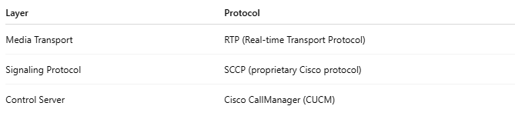
Layer | Protocol
Media Transport | RTP (Real-time Transport Protocol)
Signaling Protocol | SCCP (proprietary Cisco protocol)
Control Server | Cisco CallManager (CUCM)

🧭 SCCP Call Flow (Simplified)
# Source: Chatgpt (GPT-5-Mini) at [1/18/2026]
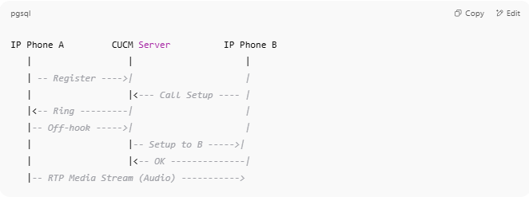
IP Phone A CUCM Server IP Phone B
| | |
| -- Register ---->| |
| |<--- Call Setup ---- |
|<-- Ring ---------| |
|-- Off-hook ----->| |
| |-- Setup to B ----->|
| |<-- OK --------------|
|-- RTP Media Stream (Audio) ----------->

- All signaling flows through CUCM.
- RTP media is peer-to-peer between phones.

🆚 SCCP vs SIP
# Source: Chatgpt (GPT-5-Mini) at [1/18/2026]
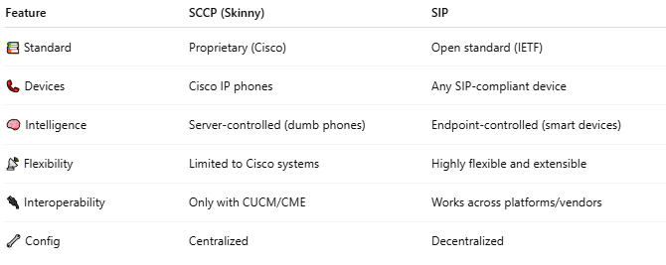
Feature | SCCP (Skinny) | SIP
📚 Standard | Proprietary (Cisco) | Open standard (IETF)
📞 Devices | Cisco IP phones | Any SIP-compliant device
🧠 Intelligence | Server-controlled (dumb phones) | Endpoint-controlled (smart devices)
📡 Flexibility | Limited to Cisco systems | Highly flexible and extensible
🔌 Interoperability | Only with CUCM/CME | Works across platforms/vendors
🔧 Config | Centralized | Decentralized

✅ Where SCCP Is Used
# Source: Chatgpt (GPT-5-Mini) at [1/18/2026]
- Cisco-based enterprise phone systems
- Cisco Unified Communications Manager (CUCM)
- Cisco Unified CME (router-based VoIP)

📌 Summary
# Source: Chatgpt (GPT-5-Mini) at [1/18/2026]
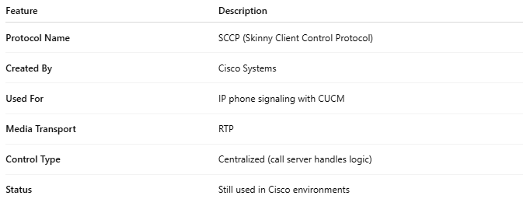
Feature | Description
Protocol Name | SCCP (Skinny Client Control Protocol)
Created By | Cisco Systems
Used For | IP phone signaling with CUCM
Media Transport | RTP
Control Type | Centralized (call server handles logic)
Status | Still used in Cisco environments

